PRESS INFORMATION

Open Education: Focus of Chemmedia AG at the Online Educa

Presentation of the open, cost-free learning environment Open KnowledgeWorker

Chemnitz, November 18, 2013 – „Knowledge is good. Sharing knowledge is better " – Open KnowledgeWorker, which is being presented by the Chemnitz e-learning provider Chemmedia AG at the Online Educa from December 4 through 6 in Berlin, fully reflects the spirit of open education. The open platform not only allows educational content to be created easily and at no cost, but also to be easily edited, saved, used again, and exchanged. This greatly facilitates collecting, distributing, and accessing knowledge. “Open KnowledgeWorker is our contribution to more open education. We think that everyone should have access to high-quality learning materials”, says Lars Fassmann, Chief Executive Officer of Chemmedia AG. And he isn’t just thinking of Europe. The open leaning environment is particularly suited for use in so-called developing countries to complement existing teaching materials and contribute to developing and improving education. “The exchange of knowledge between nations is the most effective form of development cooperation. Germany would do well to give up its position as third largest weapons exporter and instead focus on becoming the largest platform for knowledge. Open KnowledgeWorker offers a good foundation for this. Initial pilot projects, in Kyrgyzstan for example, have already begun. Computer science courses are being created there which can also be used by German universities”, Fassmann states.

Open KnowledgeWorker at stand A21
Chemmedia AG will be providing information about the advantages and use of Open KnowledgeWorker at their stand A21 at the Online Educa. Alexander Buze, head of Chemmedia AG’s KnowledgeWorker Services, will present the platform on December 5 from 14:00 to 16:00 at the Talking Heads session. Title: “Trends in Knowledge Transfer Systems: Crowd-Sourced Educational Resources with Open KnowledgeWorker”. At the same time, Stefan Tippmann, project manager at Springer Medizin, will give a talk on "E-Learning as Sales Strategy: Continuing Medical Education for the Healthcare Market”, presenting a best practice example of continuing medical education that was realized in cooperation with Chemmedia AG.

Sharing knowledge and contributing one’s own pedagogical components
The target group for Open KnowledgeWorkers includes everyone who wants to make their knowledge available free of cost: schools, universities and vocational schools, professors, college lecturers, businesses, associations, and organizations all the way up to federal politics. „Thanks to the numerous existing templates, absolutely no programming background is necessary to didactically structure and process knowledge using Open KnowledgeWorker. It is just as easy to adapt the knowledge to different audiences and translate it for global use “, explains Alexander Buze. At the same time, users as authors can incorporate the entire range of media. Using this technology is extremely simple: content and media are created with just a few clicks and existing modules can be recombined repeatedly and shared with other users through social media. You can learn anywhere – whether it be on Facebook, as a presentation, an online course, or an e-book. Since the contents are saved in the Cloud, educational institutions do not require their own server. The contents are royalty-free (Creative Commons).

You would like to arrange a press conference or an interview with a representative of Chemmedia AG? Then send us an e-mail with your wishes and proposed dates: redaktion@text-ur.de

About Chemmedia AG:
Chemmedia AG – experts for global knowledge transfer - improves the added value of their customers by successfully organizing knowledge processes and providing knowledge resources. The portfolio encompasses creating customer-specific e-learning courses, author tools, such as the popular Knowledgeworker, learning management systems to administrate online and face-to-face training, as well as portal systems and search solutions. The owner-run company, with its headquarters in Chemnitz (Saxony, Germany) and international branches, has a team of over 60 employees with international experience. Long-standing customers include Pfizer, METRO, Springer Medizin, Fressnapf, Dyson, and Biologische Heilmittel Heel, among others. Customers in Switzerland are serviced by Chemmedia Schweiz GmbH.
Contact Chemmedia AG:
Chemmedia AG . Lars Fassmann . Parkstr. 35 . 09120 Chemnitz, Germany
Tel: +40 - 371 – 49 370 0 . fassmann@chemmedia.de . www.chemmedia.de

Printable graphic material for this briefing: http://www.text-ur.de/de/newsroom/kundedetail/chemmedia-AG

Photo preview:

 | 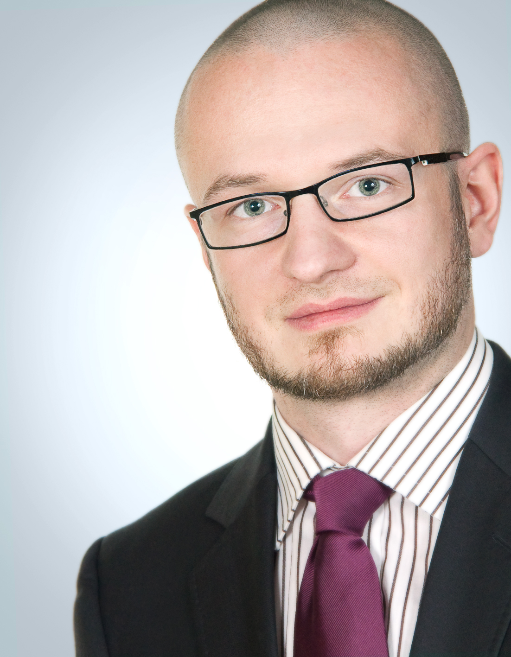
Lars Fassmann,  CEO Chemmedia AG | Alexander Buze  Head of KnowledgeWorker Services,Chemmedia AG

